Inheritance of the fluorescent glow trait in genetically engineered GloFish© Joe Burger
Background: The inheritance of any trait within a living organism is affected by the genes it carries which may or may not instruct the organism to develop the trait. These biological instructions come in the forms of genes, or specific regions of an organism’s genetic code. The genetic code, made up of DNA is common among all living things! This commonality makes the instructions for creating traits interchangeable among many different animals, plants and fungi. Recently genetic engineering has allowed the “transplant” of these traits from some organisms to others who would otherwise never be able to express them. One example of this practice in action is the transplant of a gene from jellyfish that causes them to glow green. This ability was given to zebrafish which, once glowing were renamed GloFish. Their newly acquired glow genes enable them to display many different colors when viewed under a black light! The genes for different colors can be passed on from generation to generation, a lot like hair color in humans. Each gene controlling the development and presence of a color can be thought of as light switch being on or off. The color is on if the trait is dominant. The color is off if the trait is recessive. In GloFish, the final color expressed usually depends on two such switches, meaning that color combinations are possible!
Interestingly enough there can be incomplete dominance between two genes or the switches which control two different colors. For example, a fish that is dominant or “on” for both of two different colors can be a combination of these two because they are both present. Think of this like mixing yellow and blue paint to get green! This being said let us consider a hypothetical mating between a red fish and a yellow fish. The red has the instructions for red coloring but the switch to make yellow is off. In the yellow fish the red switch is off but the yellow switch is on and causing yellow coloring.
& X &
=
&
Concept check:
1. What would a mating of a red fish to a fish with no dominant genes (on switches) produce? (Hint: All possible combinations of the two color genes between the two… Two “off” switches is called a wild type and appears grey!)
2. What would a red fish mated to an orange fish create? (Hint: All possible combinations of the two color genes between the two.)
Genotypes: Light switches to genotypes!
There are two different color switches (genes) in each fish in this example and within each switch there are two more subswitches and can be either both on (GloRed/GloRed) meaning the presence of red color, both off (Glo-/Glo-) meaning no color, or one on, one off (GloRed-/Glo-) which produces the same color as if both were on! You can see here how the sub switches get combined in a GloFish offspring.
X
Red fish Yellow fish
GloRed/GloRed; Glo-/Glo- = Glo-/Glo-; GloYel/GloYel
Orange Fish
GloRed/Glo- ; GloYel/Glo-
Red Fish  Yellow Fish | GloRed | GloRed
Glo- | GloRed/Glo-  1 | GloRed/ Glo-  2
Glo- | GloRed/ Glo-  3 | GloRed/ Glo-  4
Punnett Squares: Each table represents one of the color genes, each square along the top and side are the sub-switches present in each parental fish. These show the mixing of the sub-switches within each color gene. The same numbered square is then combined from each table to give the total coloring configuration and genotype of that offspring. The combinations of the four squares below show that the probability of getting an orange fish (GloRed/Glo- & GloYel/Glo- ) from this mating is 4/4. To determine the probability of an offspring with a different type of parents, write out all type combos from each of the 4 squares, then see what color the combo is expected to make. The probability is then the total amount of squares that make that color divided by 4.
Red Fish  Yellow Fish | Glo- | Glo-
GloYel | GloYel/Glo-  1 | GloYel/Glo-  2
GloYel | GloYel/Glo-  3 | GloYel/Glo-  4

Chi-Squared background: A chi squared test is a method used to determine the accuracy of a guess as to whether a trait is dominant (expressed in the presence of another) or recessive (not expressed in the presence of another.)
Exercise: If you found that a blue fish (similar to the red fish in its structure of genotype) had mated with a wildtype (grey) fish and produced 7 blue and 6 grey baby fish. Write a hypothesis stating whether the color gene in GloFish is dominant or recessive to the wildtype and fill out the tables to see if something FISHY is going on!
Hypothesis:
Blue Fish
Wildtype Fish
 | 1 | 2
 | 3 | 4
Blue Fish
Wildtype Fish
 | 1 | 2
 | 3 | 4

-The number expected is calculated by multiplying the probability of each color by the total # of offspring.
Fish Color | Number Observed (o) | Number Expected (e) | d =(o – e) | d² | d²/e
Total = X² Value

Analysis:
-The chi-squared value is the sum of all the numbers in the last column in the above table, and is the first number that goes into reading a chi squared table.
-The degrees of freedom is (the # of different possible types (colors) of fish possible from a cross -1), this is the second number used to read a chi-squared table.
The degrees of freedom are found along the top and determine the column to look in, while the possible X² values are found within the chart and determine the row.
The p-value is read off of the rightmost column and corresponds to a percentage of certainty. The closer your p-value is to .99 which can be thought of as 99%....the better. This means that any differences between the numbers of fish that you observed and what you should have seen are 99% due to chance. (this is good… it means nothing fishy is going on) It means that your guess was accurate and that your prediction about the dominance of the color/colors observed is most likely accurate. If you get a p-value lower than 0.5 it means that there are more factors affecting the outcome of your cross and the hypothesis needs to be redesigned.
Concept check: 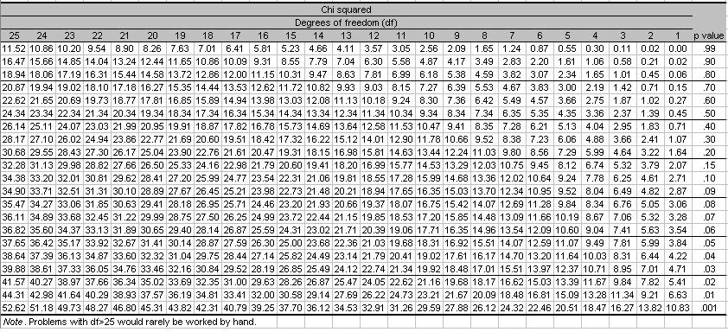
1.What was your X² Value? Your degrees of freedom?

2.What was your p-value?

3.Does your p-value support your hypothesis? What can you say about the inheritance of blue/red coloring in GloFish (dominant or recessive)?

